PART I: Biological Neural Network & Artificial Neural Network (30 Points)
Question 1.1:
Describe (including images for illustration) the human biological neural network and how it works
Answer: Human biological neural network consists of cells called as neuron. These are specialized cells which receive, process and transmit the processed information from the brain to other parts of the body and vice-versa. This communication is done via sending chemicals called as neurotransmitters.

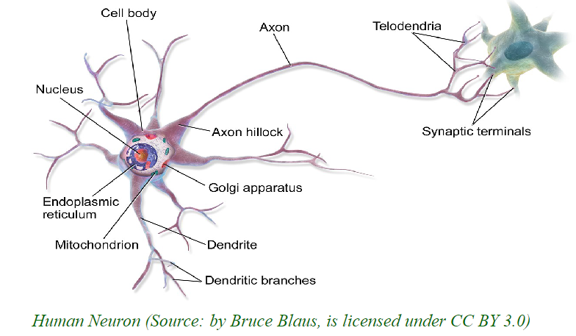
Figure: Human brain cell also called as neuron (Source: ai_dl_deep_learning_modern_AI_approach.pdf)
The major components of a neuron are:
Dendrite: The extensions are called as dendrite. They receive signals.
Cell body: The cell body contains the nucleus which is the brain of this cell and processes the information.
Axon: is the tail like structure and helps in building the long and extensive neural network.
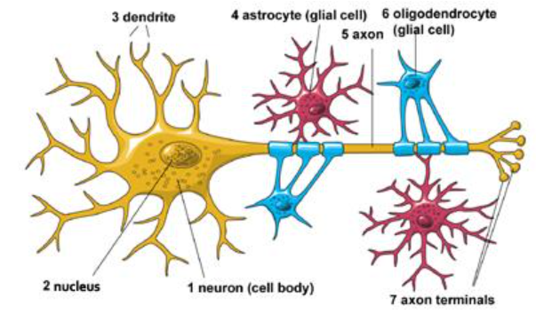
Figure: Components of neuron (Source: https://www.ninds.nih.gov/health-information/public-education/brain-basics/brain-basics-life-and-death-neuron#:~:text=Neurons%20communicate%20with%20each%20other,and%20dendrites%20of%20nearby%20neurons.&text=There%20are%20three%20kinds%20of,and%20ears)%20to%20the%20brain.)
There are three types of neurons:
- Sensory neurons are responsible for carrying information from sense organs like eyes and ears to the brain.
- Motor neurons are responsible for controlling voluntary muscle activity like walking and talking. These cells carry messages from nerve cells in the brain to the muscles.
- Interneurons are responsible for making connections between the sensory and motor neurons.
The below diagram shows these three neurons and their structure.
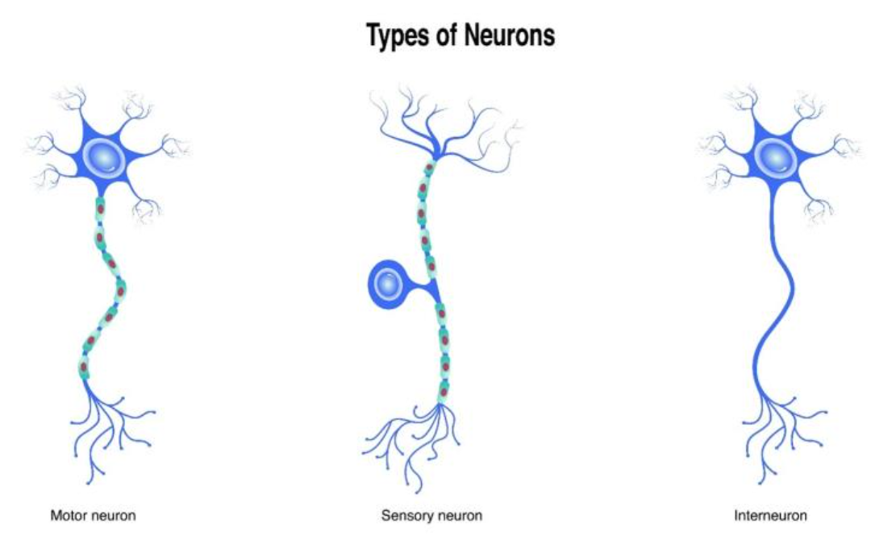
Figure: Types of neuron (Source: https://www.ninds.nih.gov/health-information/public-education/brain-basics/brain-basics-life-and-death-neuron#:~:text=Neurons%20communicate%20with%20each%20other,and%20dendrites%20of%20nearby%20neurons.&text=There%20are%20three%20kinds%20of,and%20ears)%20to%20the%20brain.)
Question 1.2:
Describe (including images for illustration) the McCulloch-Pitt neuron model, a.k.a. Threshold Logic Unit, that is considered as the simplest neural network and how it works.
Answer: The earliest neural network dates to 1943, a seminar paper “A Logical Calculus of Ideas Immanent in Nervous Activity” was published by McCulloch & Pitts. This paper proposed the first mathematical model of neural network. The below diagram shows the simple formalized McCulloch Pitts neuron which is the simplest single-layer neural network.

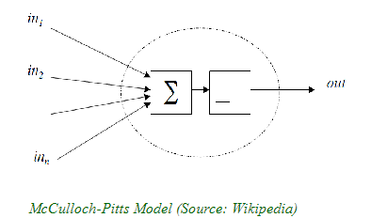
Figure: McCulloch-Pitts neural model (Source: Course material: ai_dl_deep_learning_modern_AI_approach.pdf)

Components of Mcculloch-Pitts neuron:
- The neuron takes the inputs as in1, in2, in3 etc. It is the computational unit.
- Summation function calculates the sum of the inputs.
- Activation Function/Step Function: if the output of the summation function is greater than the required threshold, the output is 1 else it is 0.
Question 1.3:
Discuss (including images for illustration) how the pioneers in the AI field did imitate the human biological brain system to conceive the first artificial neural networks
Answer: McCulloch-Pitts Neuron is the building block of the initial neural network. Inspired by the human brain cell it could facilitate multiple inputs, process it and generate the output. It was a simple single-layer neural network and was not capable of complex operations like multiple classification.
Back Propagation: Next came the backpropagation mechanism in the year1970 which were inspired by the synaptic plasticity of the brain cell. In this process, the brain updates the strength of connections among the neurons and improves performance.
Multilayer Perceptrons: It is the similar mechanism of MCP implemented in multiple layers.
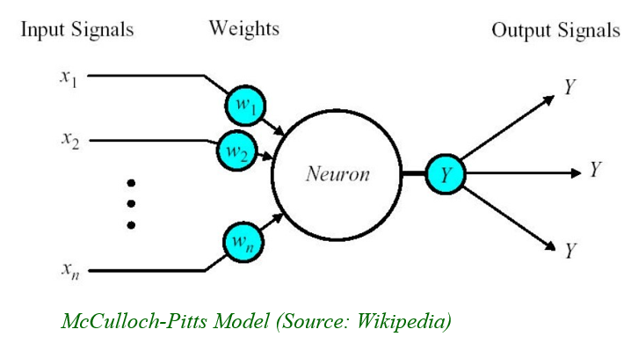
Figure: McCulloch-Pitts neural model (Source: Course material: ann_fundamentals_of_artificial_neural_networks_PART_II)

PART II: Linear Algebra for Deep Learning: Matrices (25 Points)
TO-DO
Given the following matrices:

5 3 8
A = [ ] B = ?
2 −1 7

--) Provide a matrix with all the scalar elements for B and perform the dot multiplication A * B

SUBMISSION REQUIREMENT PART II

--) Matrix B with all its scalar elements
--) The result of C = A * B
--) Specify the dimensions of C
--) Explain how to get the dot product C = A * B

Answer: I have followed the below lecture slide to perform the matrix multiplication.
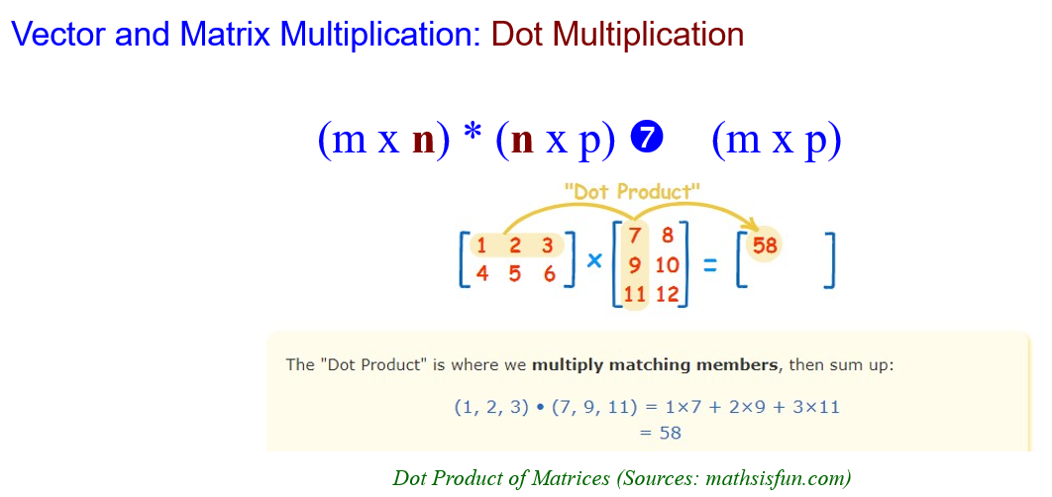
Dimension of matrix A: 2X3 (2 rows and 3 columns)
Dimension of Matrix B: 3X2 (3 rows and 2 columns)
Dimension of the result matrix C: 2X2 (2 rows and 2 columns)
Explanation of dot product (matrix multiplication):
Let the elements of result matrix C be c11, c12, c21, c22
- C11=a11*b11+a12*b21+a13*b31.
- C12=a11*b21+a12*b22+a13*b32
- C21=a21*b11+a22*b21+a23*b31
- C22=a21*b12+a22*b22+a23*b32
I have performed the matrix multiplication on paper which is shown below.
The result matrix C = c11=35, c12=83, c21=21, c22=45.
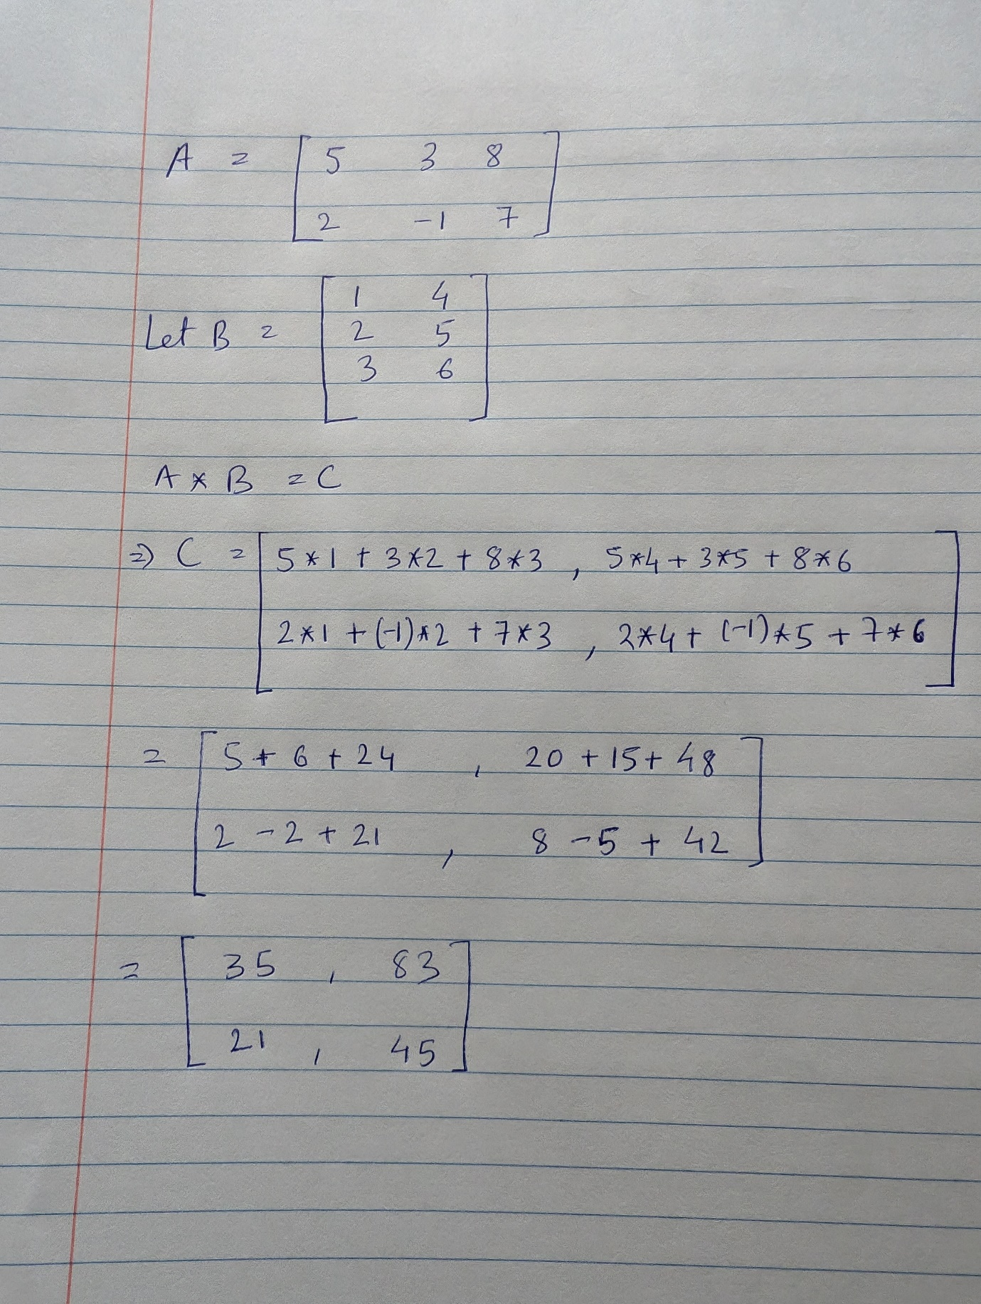
Figure: matrix multiplication done on paper

PART III: Linear Algebra for Deep Learning: Matrices (45 Points)
TO-DO

Given the following matrix as a 2D array:

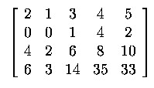
--) Question 3.1:
Let’s consider this matrix as a vector of vectors.
How many vector elements does this matrix have, long Axis 1? Show each vector element, one by one.
Answer: This is vector of vectors where each row represents a vector. As the matrix has four rows there are four vectors.
Vector1= [2 1 3 4 5]
Vector 2= [0 0 1 4 2]
Vector 3=[4 2 6 8 10]
Vector 4=[6 3 14 35 33]
--) Question 3.2:
Let’s consider this matrix as a vector of vectors.
Add 3 to the vector element (of the matrix) of the index = 1. The addition is performed elementwise along Axis 1. Display the matrix with all its scalar elements after the operation has been done in the format of a 2Dmatrix.
Answer: The given 2D array is:
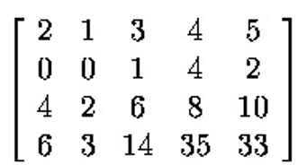
Index 1 = [0 0 1 4 2]
Adding 3 to index 1: [0+3 0+3 1+3 4+3 2+3] = [3 3 4 7 5]
Resultant Matrix:
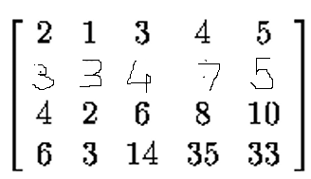
--) Question 3.3:
Continuing from Question 3.2, i.e., after the above addition of 3 has been done: Flatten the matrix and display the result.
Answer: Flattening the matrix:

Result: [2 1 3 4 5 3 3 4 7 5 4 2 6 8 10 6 3 14 35 33]

